LESSON NOTES FOR READING FOR MIDDLE CLASS TERM I – 2026

WEEK I

Lesson one
TOPIC: Learning sounds
Evaluation activity: Pupils will read out the sound loudly
a, c, b, e, d, g
Learning materials: Single flash cards

Lesson two
TOPIC: Learning sounds
Evaluation activity: Pupils will continue reading sound loudly
a, c, b, e, d, g
Learning materials: Single flash cards

Lesson three
TOPIC: Learning sounds
Evaluation activity: Pupils will play and match sounds
“small with big”
a | b | c
d | e | f
c
d
e
g
a
f
d
a
f
e
d
c
b
a

Learning materials: Single cards

Lesson four
TOPIC: Learning sounds
Evaluation activity: Pupils will play a matching game using small and big cards.

g | c | a
e | d | f

Learning materials: Single flash cards

TOPIC: Learning sounds
Evaluation activity: Pupils will write sounds on slates or chalkboard on their own.
Learning materials: Slates, chalk/single flash cards

WEEK II

Lesson one
TOPIC: Learning sounds
Evaluation activity: Pupils will read out sounds loudly.
a, c, b, e, d, g
Learning materials: Single flash cards

Lesson two
TOPIC: Learning sounds
Evaluation activity: Pupils will copy sound “a”
 a a a
- -- --
- -- --
Learning materials: Single flash cards and real objects

Lesson three
TOPIC: Learning sounds
Evaluation activity: Pupils will copy sound “b” in books.

b b b
- - -
- - -
Learning materials: Single flash cards, real objects

Lesson four
TOPIC: Learning sounds
Evaluation activity: Pupils will copy sound “c” in books.
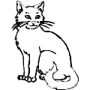
c c c
- - -
- - -
Learning materials: Single flash cards, real objects

Lesson five
TOPIC: Learning sounds
Evaluation activity: Pupils will copy sound “d”

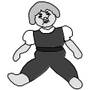
d d d
- - -
- - -
Learning materials: Single flash cards, real objects

WEEK III

Lesson one
TOPIC: Learning sounds
Evaluation activity: Pupils will copy sound “e”


e e e
- - -
- - -
Learning materials: Single flash cards, real objects

Lesson two
TOPIC: Learning sounds
Evaluation activity: Pupils will copy sound “f”


f f f
- - -
- - -
Learning materials: Single flash cards, real objects

Lesson three
TOPIC: Learning sounds
Evaluation activity: Pupils will copy sound “g”

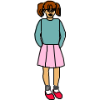
g g g
- - -
- - -
Learning materials: Single flash cards, real objects.

Lesson four
TOPIC: Learning sounds
Evaluation activity: Pupils will match the same and draw

a c __ ___
e a _____
b e _____
c b _____
Learning materials: Single flash cards, charts

Lesson five
TOPIC: Learning sounds
Evaluation activity: Pupils will match the same and draw
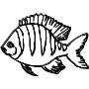
f a__ ___
d f __ ___
g d_____
a g _____
Learning materials: cards with sounds

WEEK IV
Lesson one
TOPIC: Learning sounds
Evaluation activity: Learners will recognize and circle correct sounds e.g
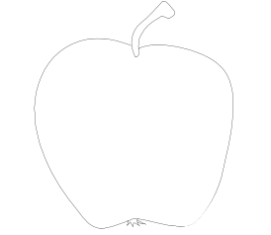

Learning materials: Single flash cards
Lesson two
TOPIC: Learning sounds
Evaluation activity: Learners will recognize and circle correct sounds e.g

Learning materials: Single flash cards

Lesson three
TOPIC: Learning sounds
Evaluation activity: Learners will circle the given sound.
d | z z d
e | x e x
f | a a f
c | s c s
Learning materials: Flash cards

Lesson four
TOPIC: Learning sounds
Evaluation activity: Learners will circle the correct sound for the picture. E.g
   | b c d
 | t a e
Learning materials: Flash cards, real objects

Lesson five
TOPIC: Learning sounds
Evaluation activity: Learners will circle the correct sound for the picture. E.g
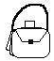 | f a b
 | e v g
Learning materials: Flash cards, real objects

WEEK V
Lesson one
TOPIC: Sounds
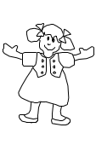
Evaluation activity: Learners will colour for the given sound e.g .

B =


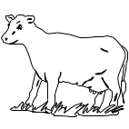

C =

Learning materials: Books and coloured pencils.

Lesson two
TOPIC: Sounds
Evaluation activity: Learners will ring the sound and colour the picture.
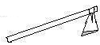
s j a

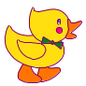
d m o
Learning materials: Books and coloured pencils.

Lesson three
TOPIC: Sounds
Evaluation activity: Learners will match sounds to pictures e.g.
b


e

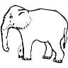
d
Learning materials: Flash cards.
Lesson three
TOPIC: Sounds
Evaluation activity: Learners will match more sounds to pictures.
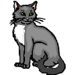
g

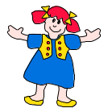
e


c
Learning materials: Flash cards.

WEEK VI
Lesson one
TOPIC: Sounds
Evaluation activity: Learners will draw pictures for the given sound.
b =
h =
e =
Learning materials: Single flash cards.

Lesson two
TOPIC: Sounds
Evaluation activity: Learners will draw pictures for the given sound.
f =
d =
a =
Learning materials: Single flash cards.

Lesson three
TOPIC: Sounds
Evaluation activity: Learners will cross the different sound.
b d b b
c a c c
e I e e
Learning aids: ………………………..
WEEK VII
Lesson one to three
TOPIC: Sounds
Evaluation activity: Learners will write sound for the given picture.




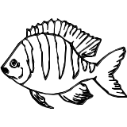

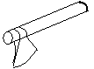

Learning materials: Real objects, single flash cards.

Lesson four to five
TOPIC: Sounds
Evaluation activity: Learners will tick the correct sound for the picture.

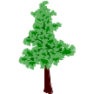
p c r
b f h
e c o
Learning materials: Real objects, single flash cards.

WEEK VII

Lesson one and two
TOPIC: Sounds
Activity: Learners will listen and write sounds. E.g
c ------ ------
----- -----
Learners will listen and write words e.g
box _____
_____ _____
_____ _____
Learning materials: Single flash cards, books and pencils

Lesson three and four
TOPIC: Sounds
Activity: Learners will fill in the given sound “a”
b__t b__g c__t t__p p__n

Learners will read and draw good pictures.
bag ______ fan ______
cat _____ box ______
Learning materials: Flash cards

Lesson five
TOPIC: Sounds
Activity: Learners will fill in the missing sounds.
p__t s__m b__g m__n
Learning materials: cards

WEEK IX
Lesson one and two
TOPIC: Sounds

Activity: Learners will name the given objects
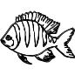
_______ _______ ______


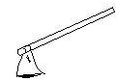
_______ _______ _______

______ _______ _______

(flower, pot, door, fish, pencil, mat, tin, axe)
Learning materials: Real objects

Lesson three to five
TOPIC: Sounds
Activity: Learners will read and draw good pictures.
tin _______ cup _______ pot______
tree _______ box _______ bed_______
book ______ man _______
Learning materials: Single flash cards

WEEK X
Lesson one to five
TOPIC: Sounds
Activity: learners will continue to read sounds
h, j, k, m, g
Learning materials: Single flash cards

TOPIC: Sounds
Activity: learners will continue to read sound “h” and write words with sound “h”
h | h | h | h
hut | hut | house | house

Learning materials: Charts and cards

Topic: Sounds
Activity: learners will read sounds and write words of the given sounds

j | j | j | j
jug | jug | jacket | jacket

k | k | k | k
kite | kite | kettle | kettle

m | m | m | m
man | man | moon | moon
man | man | moon | moon
Learning materials: Charts , cards, etc

